CHARTING CULTURE
Meaning/Nature  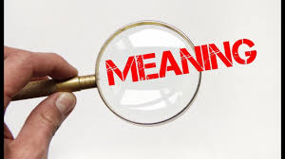  Group 1 | Elements    Group 2 | Types  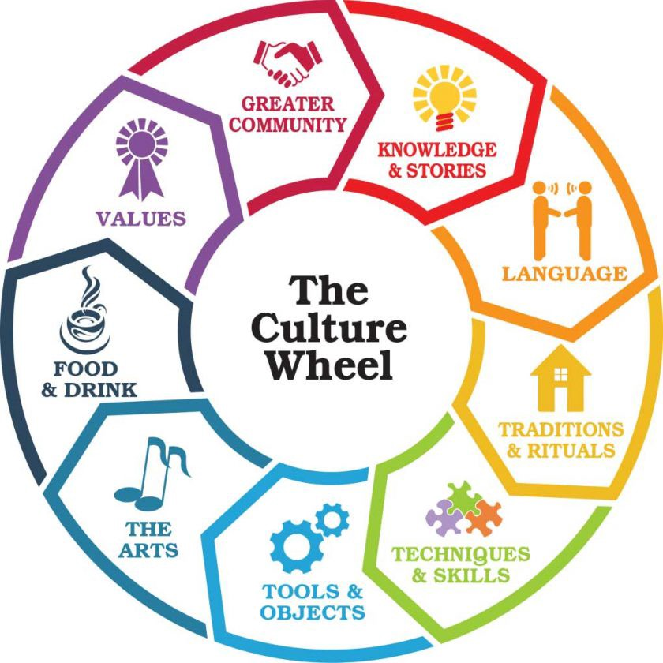  Group 3 | Characteristics  Group 4 | Processes  Group 5 | Functions  Group 7
STEM 1  Members: Abadiano, Asilo, Baluyut, Baltazar, Opalia, Rama  STEM 2  Members:  Ilagan, Lagasca, L. Mendoza, Aspera, Mayo, David  Culture as a “complex whole” and as a “way of life”  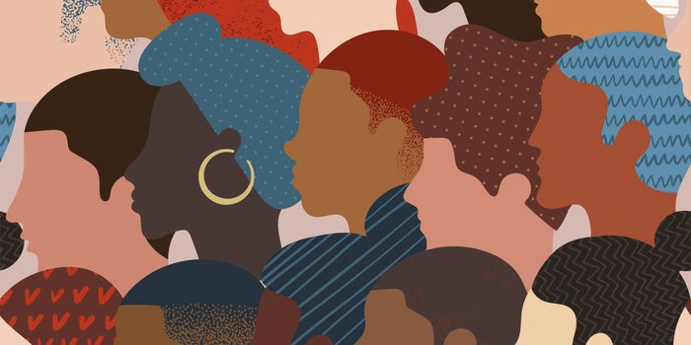  -Lagasca  Question: Why is it being referred to as such? “Complex”? “Whole”? “Way of Life”?  Culture is referred to as a complex whole because of the variety of cultures being presented to the world.  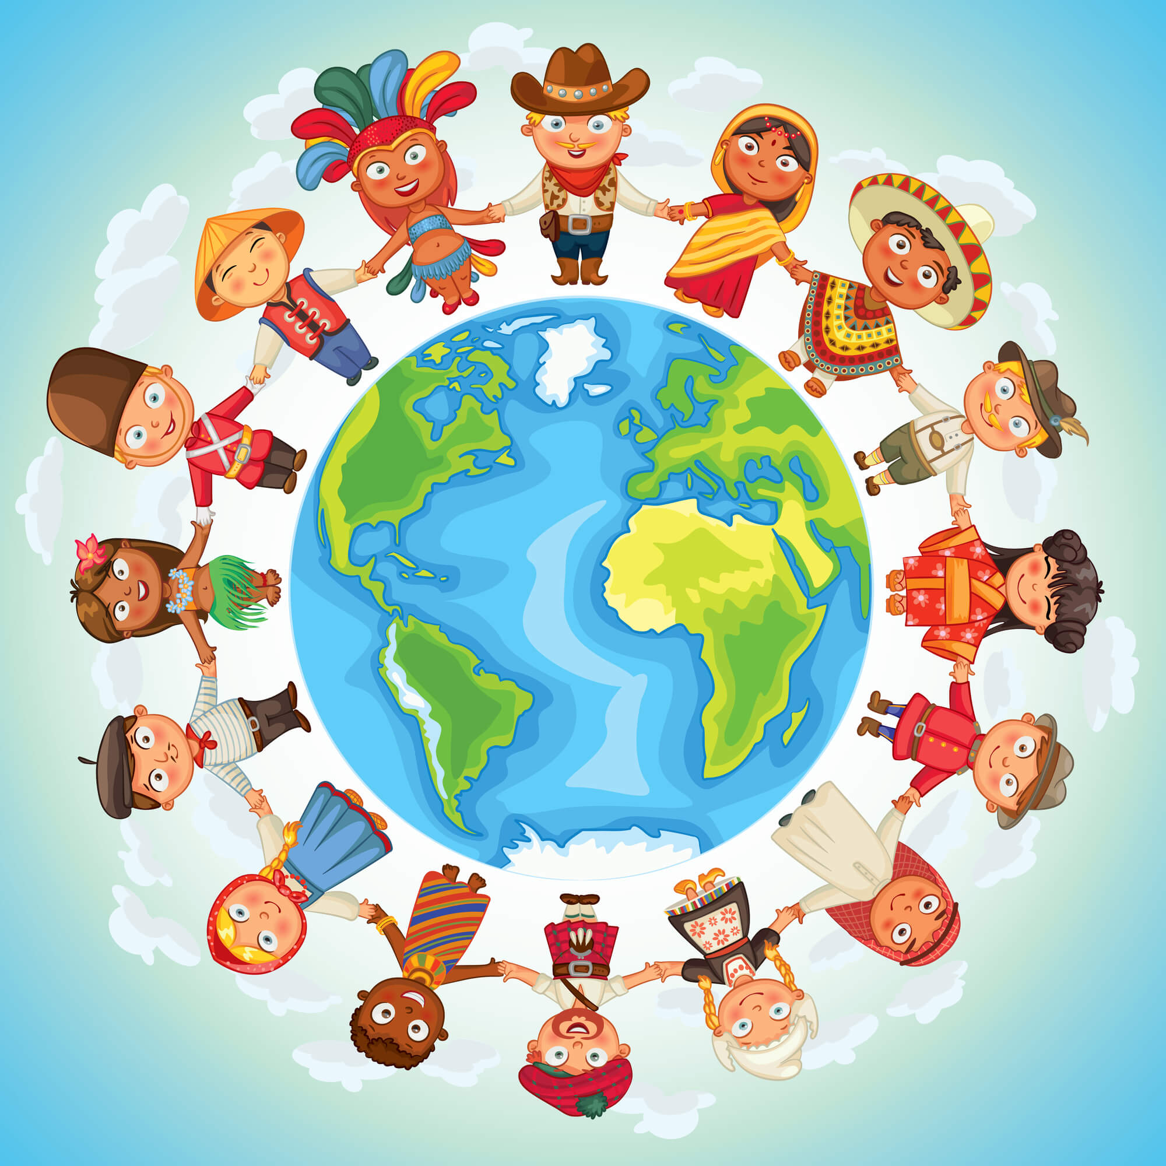  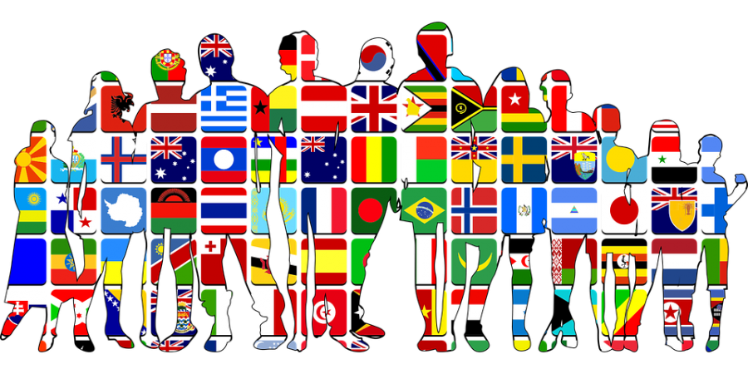  -Lagasca  Culture cannot be broken down to attributes as it is something that encompasses everything that a person believes, practices, knows and shares.  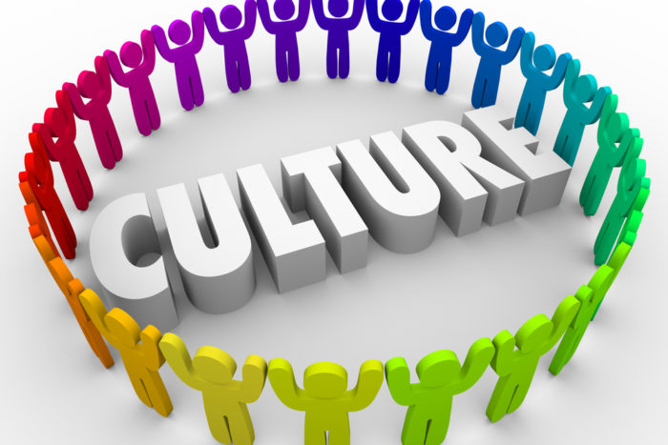  -Lagasca  There are a variety of cultures thus comes its differences and complexity in what people believe and do. Coexisting even with these differences is just a way of life.  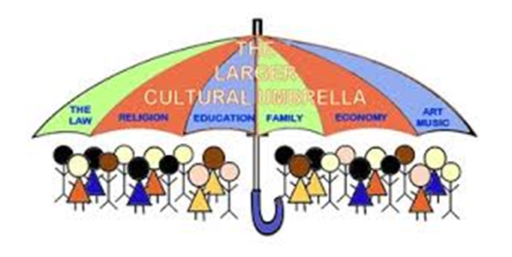Ilagan, Mikhail ↑  Culture is referred to as a way of life as it consists of the behaviors, belief, and values of people. It shapes the way we perceive and understand things therefore, without culture, there'd be no society.  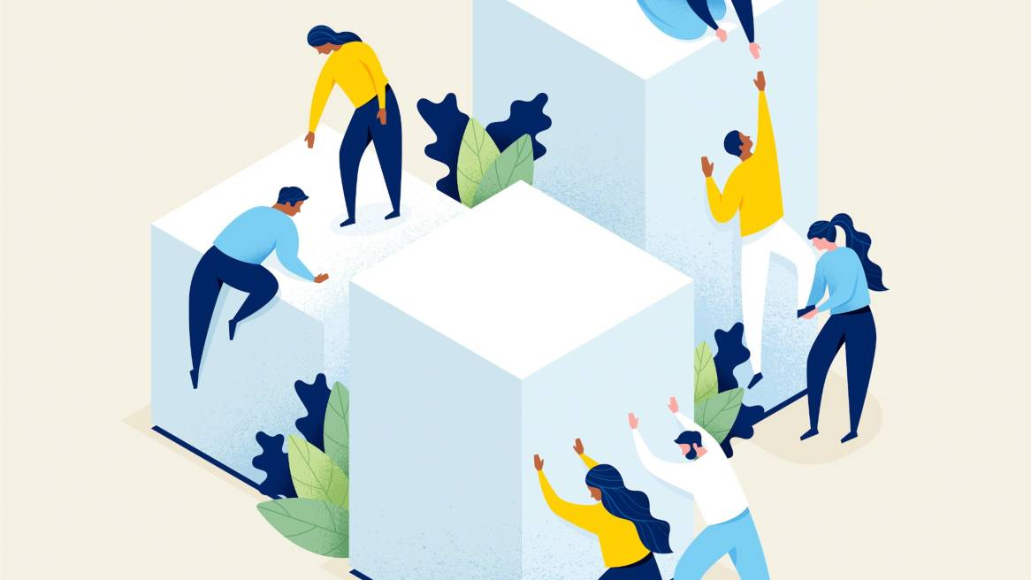  -Lagasca    -Lagasca  Our culture is our way of life, it measures our quality and vitality. We constantly develop a sense of belonging, personal and cognitive growth and the ability to empathize and relate to one another. Culture as a complex whole which encompasses knowledge, symbols, artifacts, norms, law, attitudes, values, practices, beliefs, and any other that person learns and shares as a member of a society.  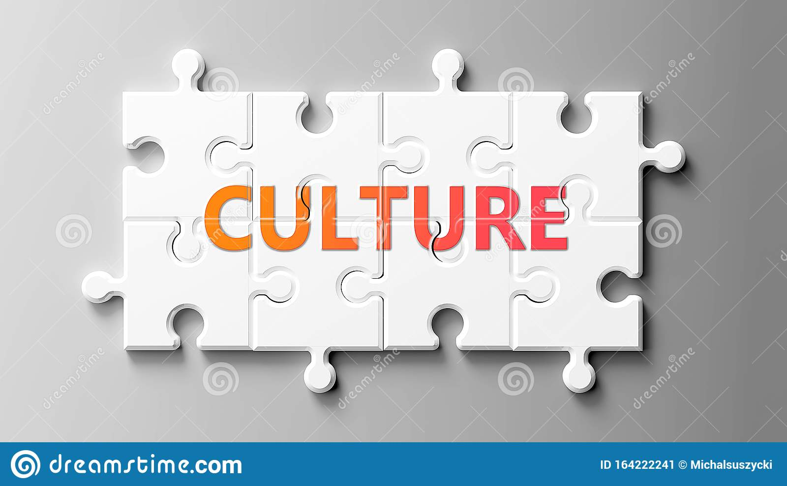  -Lagasca  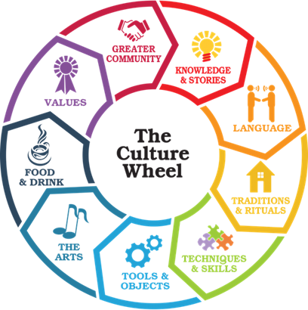  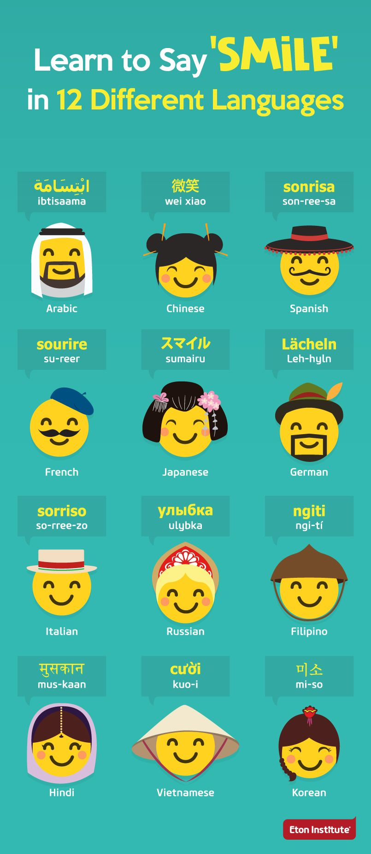 | STEM 1  Members: Aguilar, Bongalos, Lumbao, Luna, Purisima, San Miguel  STEM 2  Members:  Fideles, Badron, Ladra, Panuela, Maranan, Marquez  Give the meaning for each element of culture. Better if you can cite example/s for each element of culture.  Beliefs - These beliefs are responsible for the spiritual fulfillment of needs and wants.  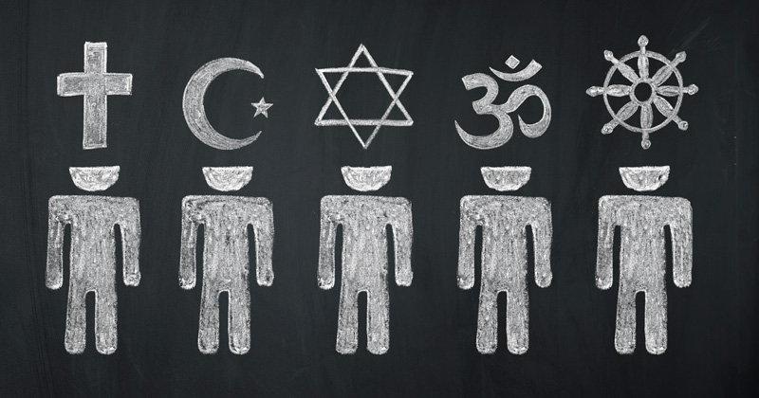  Practices - refers to the manifestation of a culture or a sub-culture, in regard to the traditional practices of a particular cultural group.  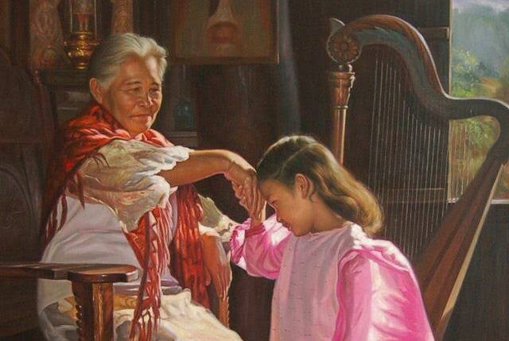  Values - these are ideas and principles of what is right, wrong, fair, and just.  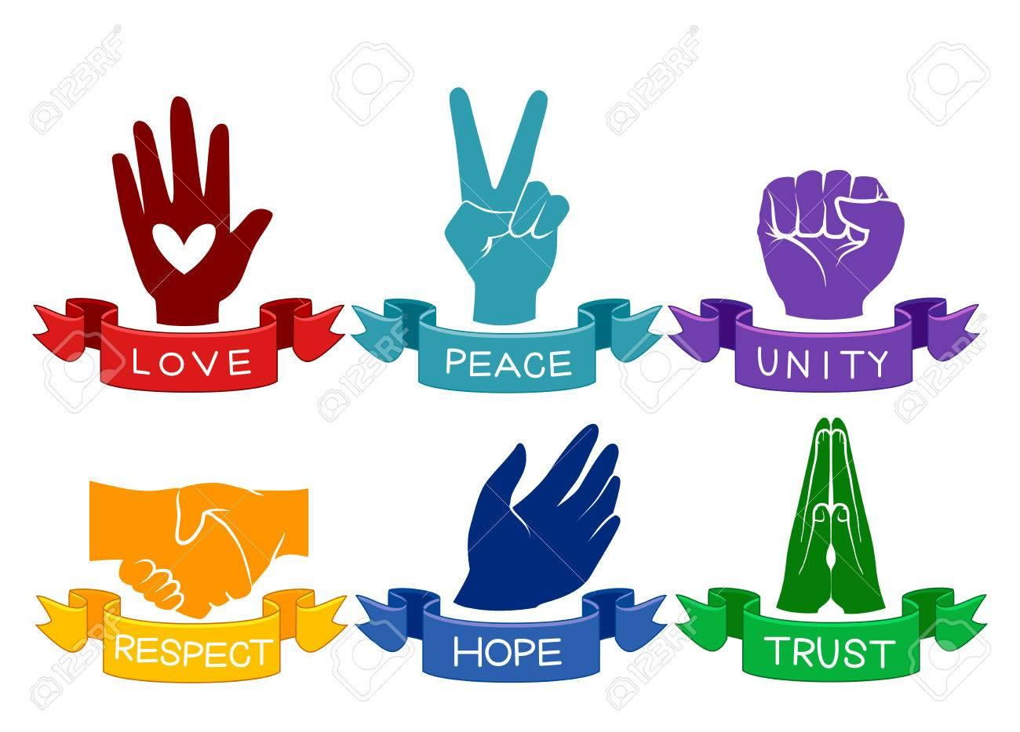  Attitudes - It is the way we have influences on how we act or behave.    Laws- this refers to the set of rules and regulations that maintains peace and order to society, it is also a driver of what people deem as right or wrong    - Fideles  Norms - define how to behave in accordance with what a society has defined as good, right, and important.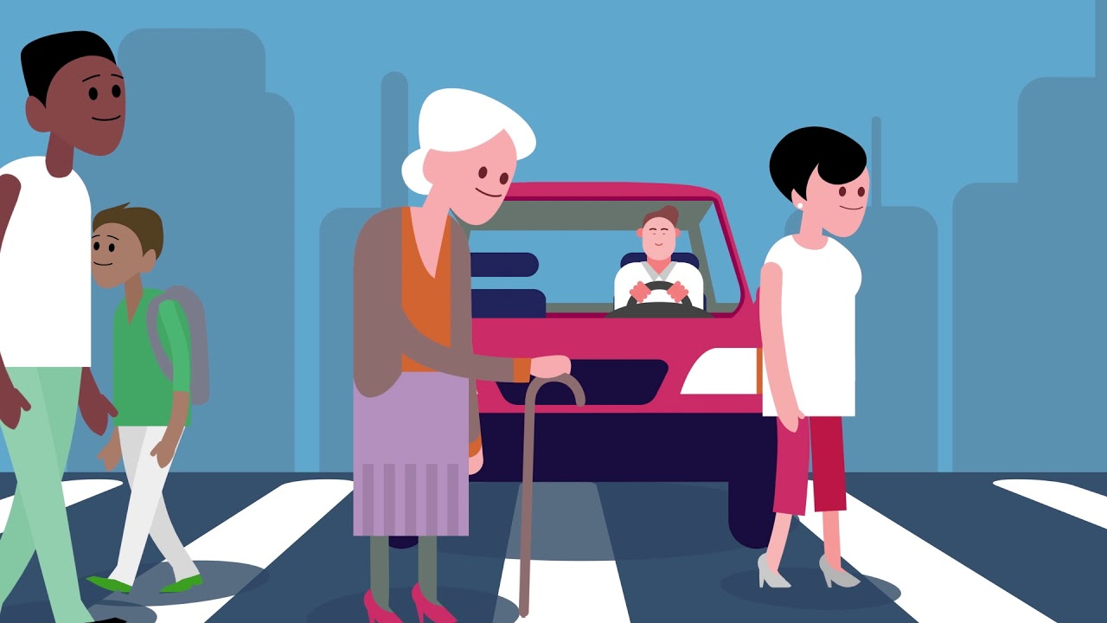  Artifacts- These are cultural or historical objects (can be: clothes, tools, jewelry, etc.) that are made by humans from before. Also, it provides essential clues for new generations in studying and understanding ancient cultures.  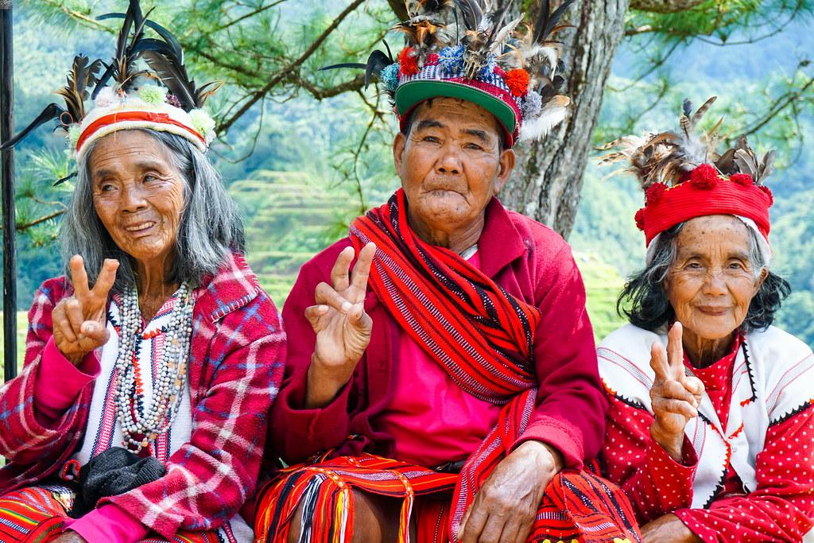  - Fideles  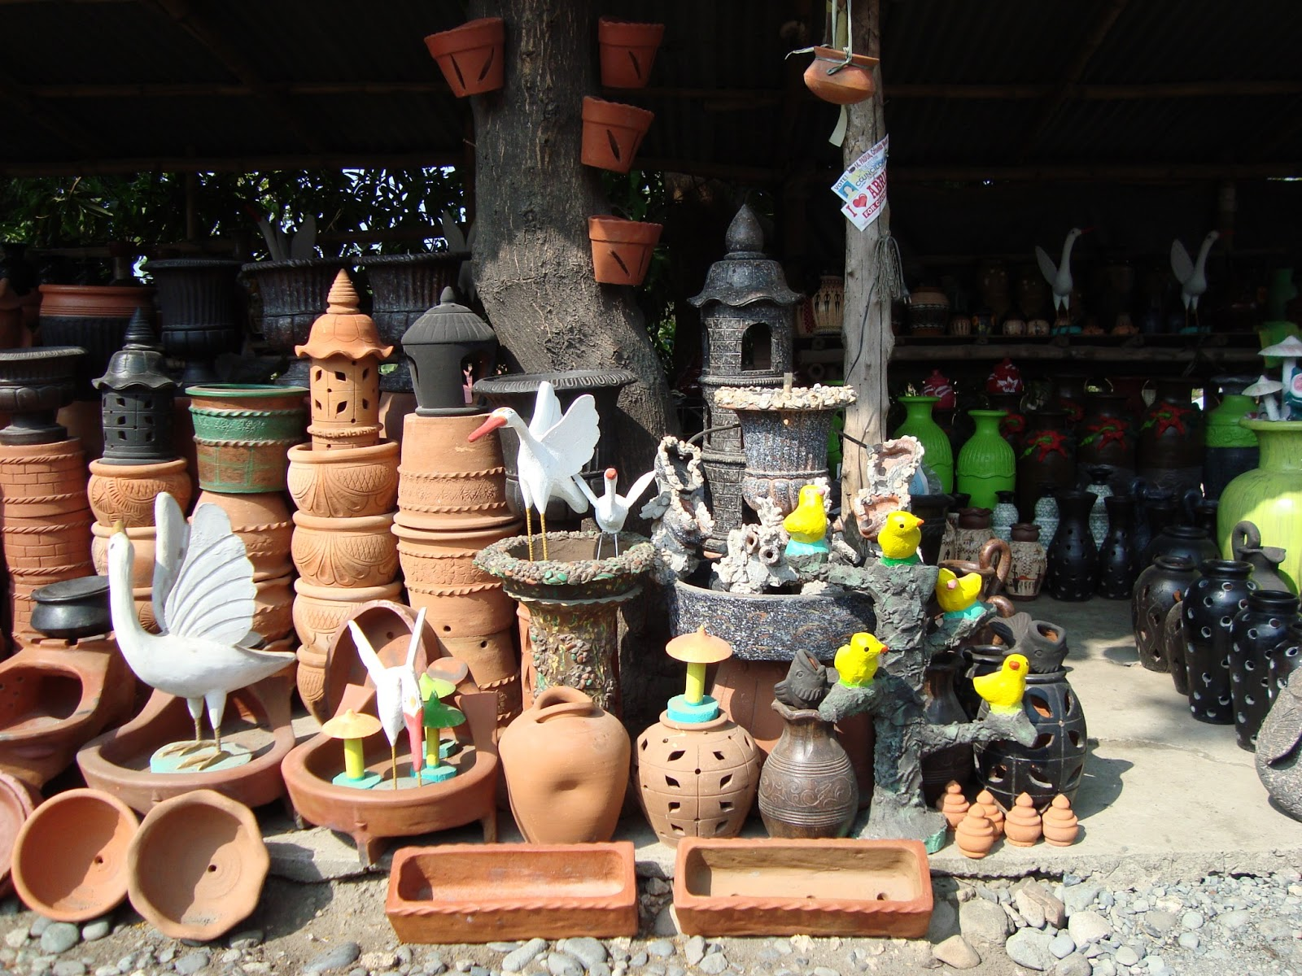  Symbols - anything that can stand as a representation of something. They are interpreted intersubjectively (involving or occurring between separate conscious minds) by social actors. Used to convey thoughts ((ex. roses=love, hug(gesture)= comfort))    - Fideles  Knowledge - that you know about some cultural characteristics, history, values, beliefs, and behaviors of another ethnic or cultural group.   | STEM 1  Members: Timothy Castillo, Reilan Vinuya, David Sulleza, Peter Parker, Dennis Hilario, Marco Maralit.  STEM 2  Members: Buna, Enriquez, Fallorina, K. Mendoza, Magcalas  Culture consists of both material culture and non-material culture. Thoughts or ideas that make up a culture are called the non-material culture. In contrast to material culture, non-material culture does not include any physical objects or artifacts.  Material culture includes things that have a physical existence and these are created by man himself. Non-material culture represents a community’s values, norms and attitudes and these do not have a material existence.  Meanings & examples  Material Culture: consists of materialistic items and architecture.  Material culture, tools,weapons,utensils,machines, ornaments, art, buildings, monuments, written records, religion images, clothing, and any other ponderable objects produced or used by humans  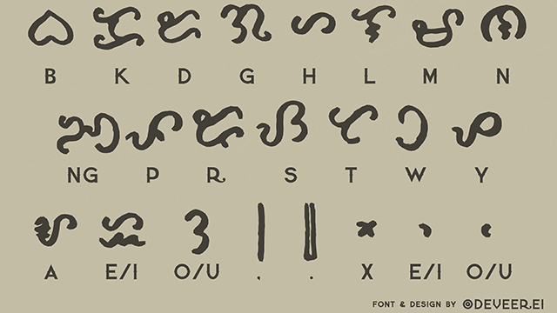  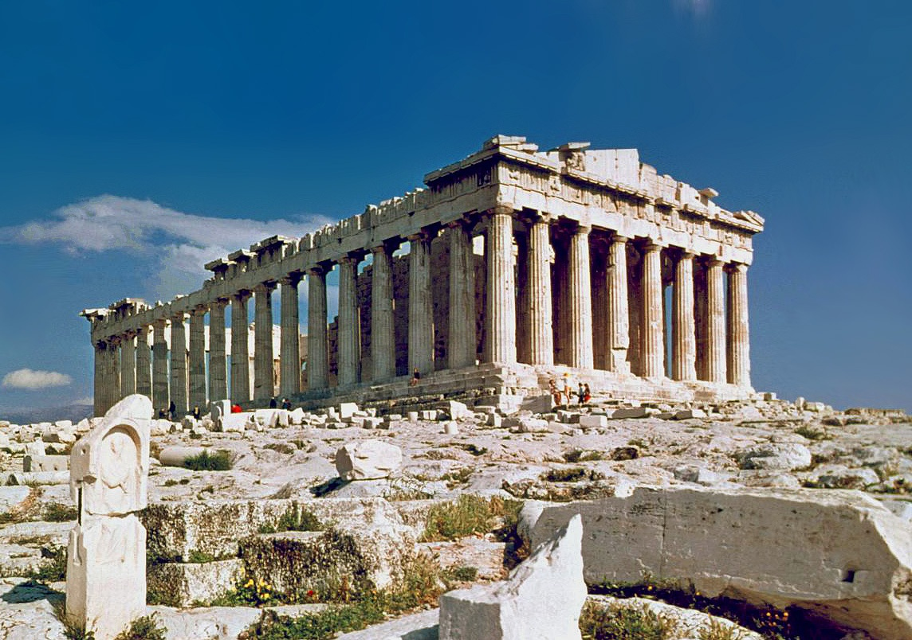  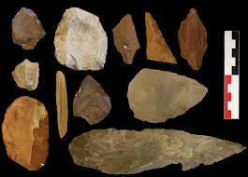  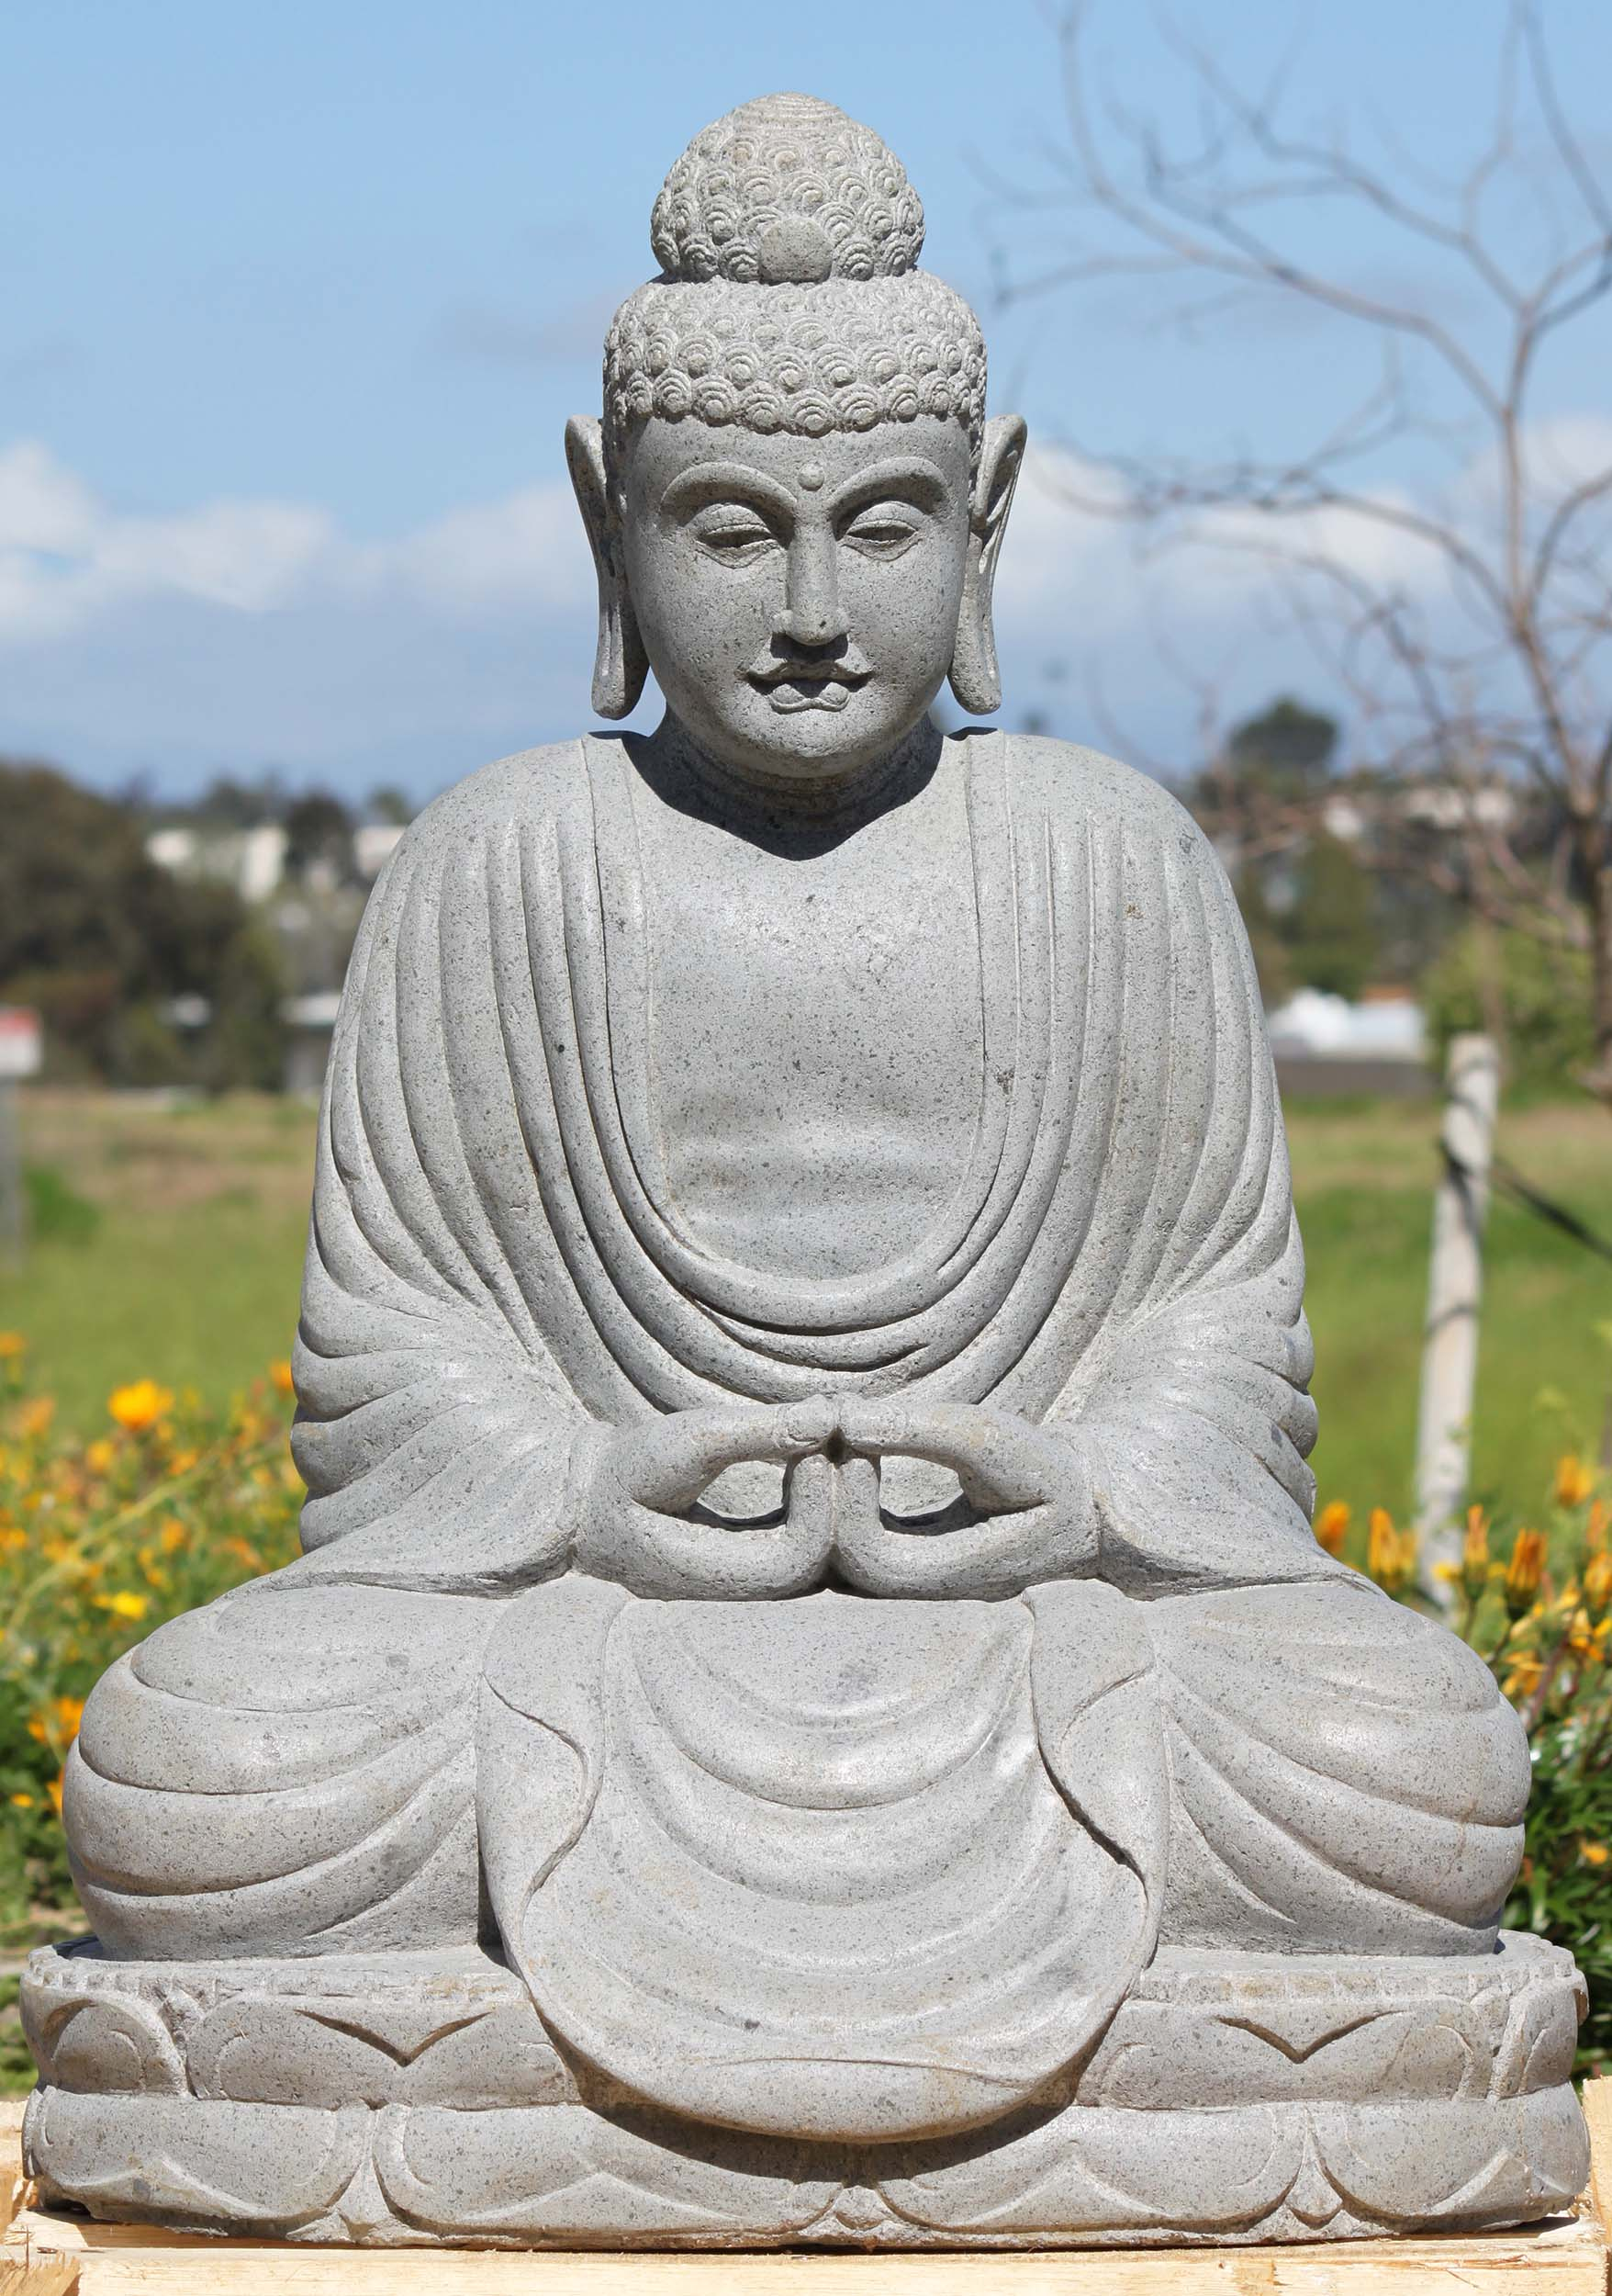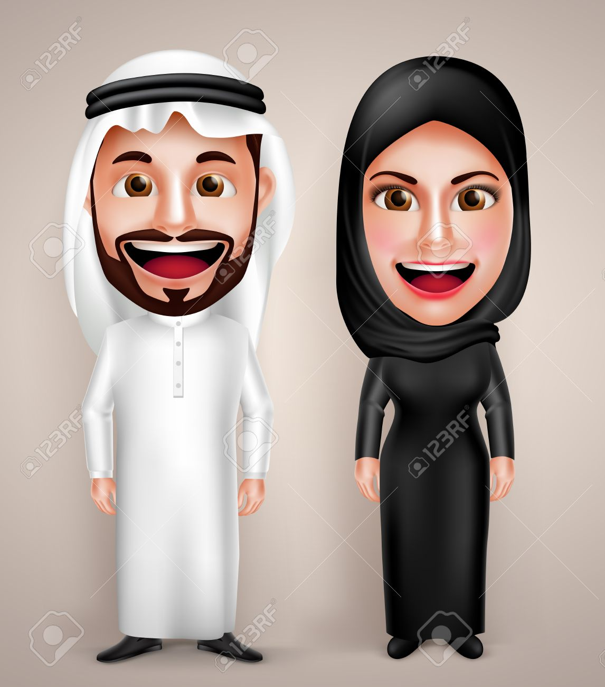  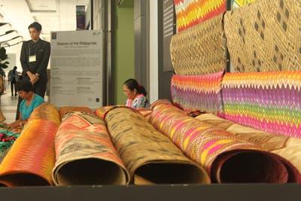  Fallorina  Non-Material Culture:  Refers to the nonphysical ideas that people have about their culture, including beliefs, values, rules, norms, morals, language, organizations, institutions. Magcalas  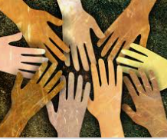  Magcalas  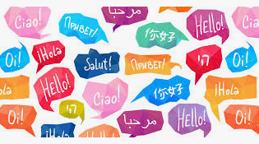  Magcalas    For instance, the non-material cultural concept is religion consists of a set of ideas and beliefs about God, Worship, morals, and ethics. These beliefs then, determine how the culture responds to its religious topics, issues, and events.  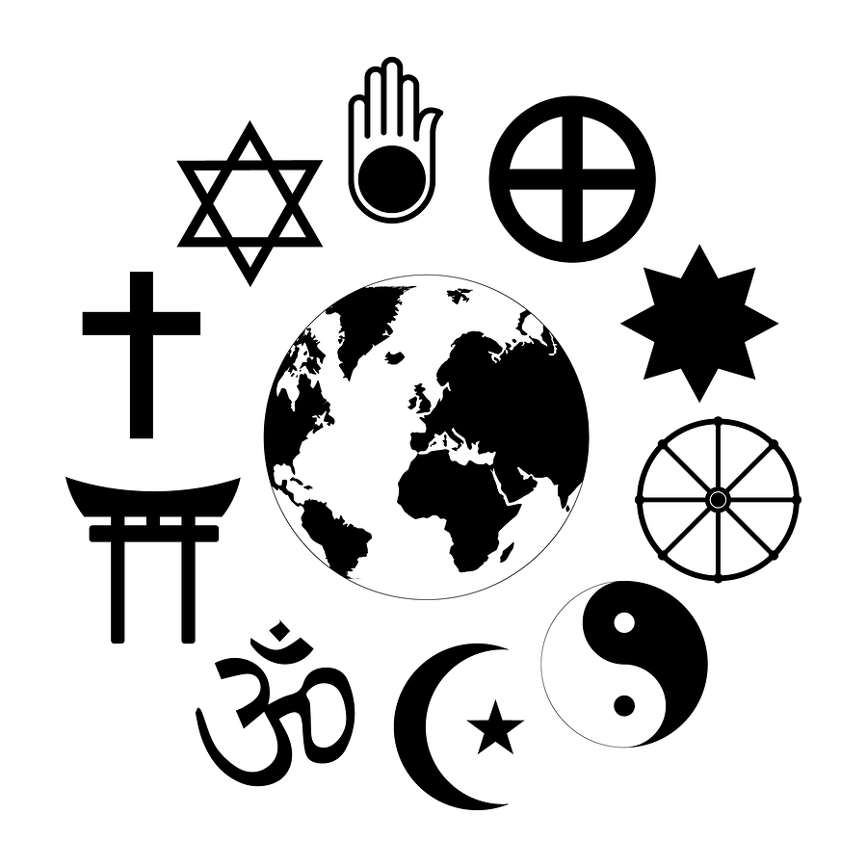  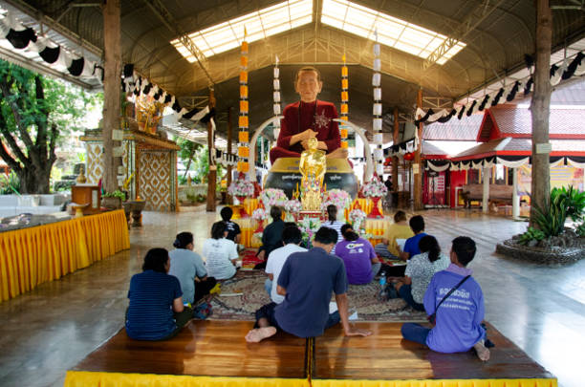  Fallorina  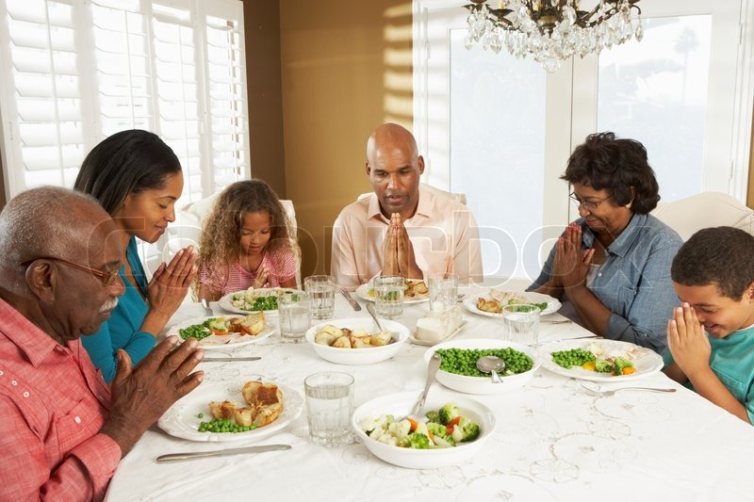  Fallorina | STEM 1  Members: Guansing, Javier, Pasandalan, Flandez, Ceniza Panganiban  STEM 2  Members: Cabangahan, Cayabyab, Manuel, Maranao, Vicente  Enumerate and explain the characteristics of culture.  1.) Culture is social because it is the product of behavior    -Cayabyab,  - Culture does not exist in isolation. It develops through social interaction. No man can acquire culture without association with others.  2.) Culture varies from society to society  - Every society has of its own that differs from other societies. The culture of every society is unique to itself. Cultures are not uniform. Culture varies from time to time as well.  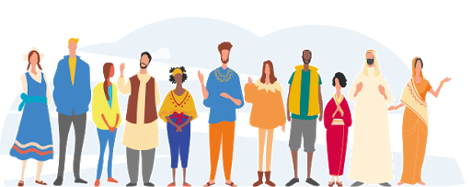  - Manuel  3.) Culture is shared - Culture is not something that an individual alone can possess. Culture is shared. For example, customs, traditions, beliefs, ideas, values, morals, and etc. are all shared by people.    - Vicente  4.) Culture is learned - Culture is not inborn but learned. Culture is often called “learned ways of behavior”. Unlearned behavior is not culture. But shaking hands, saying thanks, etc. are cultural behavior.  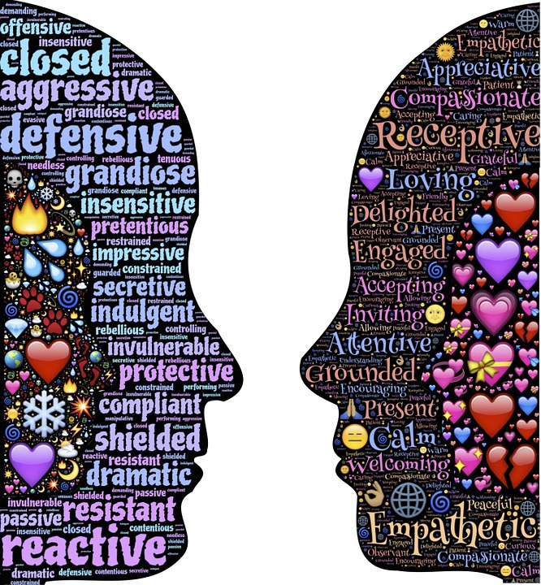  - Cabangahan  5.) Culture is transmitted among members of society - Culture is learned by persons from persons, many cultures we have are handed down by elders, parents, teachers, and others. Transmission of culture is made possible by language.  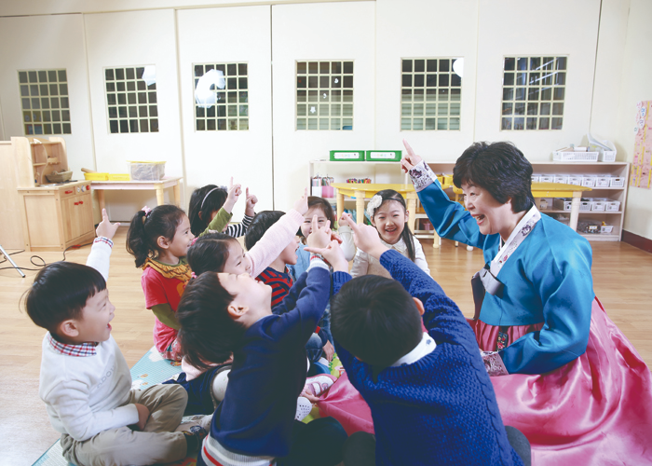  - Maranao  6.) Culture is continuous and cumulative  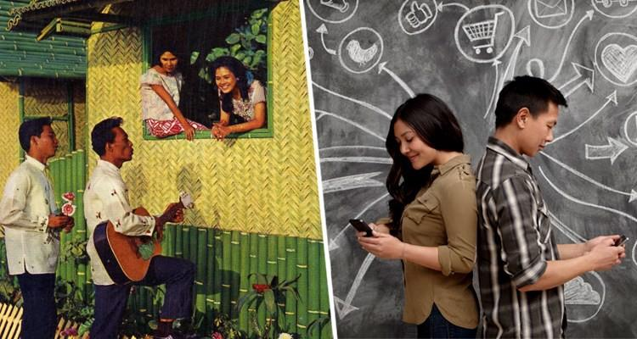  -Manuel  - culture exists as a continuous process of unending change and that every country experiences change no matter how slow or fast.  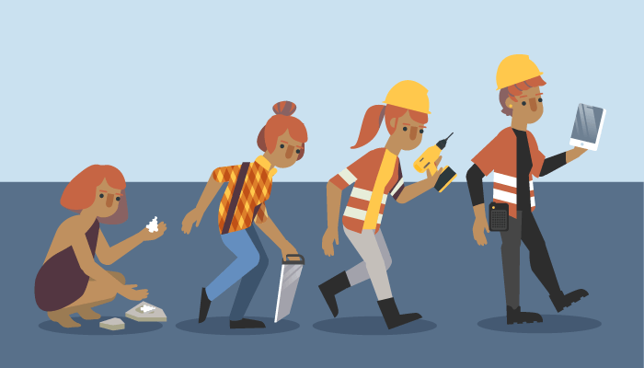  -Cayabyab  7.) Culture is gratifying and idealistic - Culture provides proper opportunities for the satisfaction of our needs and desires. It embodies the ideals, values, and norms of the group.    - Cabangahan  8. Culture is Abstract.- is shared in ways of doing and thinking.there are degrees of visibility of cultural behavior, ranging from person’ regularized activities to their internal reasons for doing so.  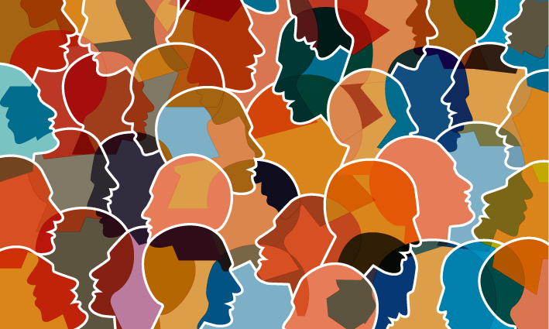  -Cayabyab | STEM 1  Members: Hafalla, Osabel, Macaraeg, Uy, Cuasay, Ibasco  STEM 2  Members:  Salazar,Quialquial,Motas, Arguelles, Hernandez, Rosillosa  Describe each of the following:  Can you cite some examples so as to enable your classmates to see clearly the distinctions? At least, one for each will do.  Enculturation- the way in which we obtain and transmit culture. This is the process where individuals learn about their own culture through experience, observation, and instruction of other people with the same culture.  Example:  Observing how your friends talk allows you to learn slang words.  Christian parents who are teaching their children to pray.  -Quialquial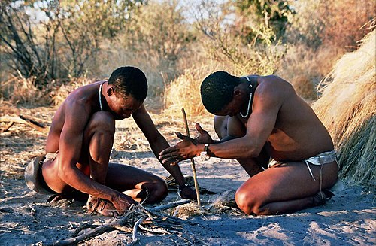  -Salazar  Acculturation- A process of social, psychological, and cultural change that stems from the balancing of two cultures while adapting to the prevailing culture of the society.  It is the process of learning and incorporating the values, beliefs, language, customs, and mannerisms by people exposed to new culture or to multicultural society. Cultural and behavioral changes take place as a result of contact between cultural groups and their members.  Example:  Immigrant acculturation that occurs as migration disrupts the development path.  Cultural exchange in food, clothing, language, etc.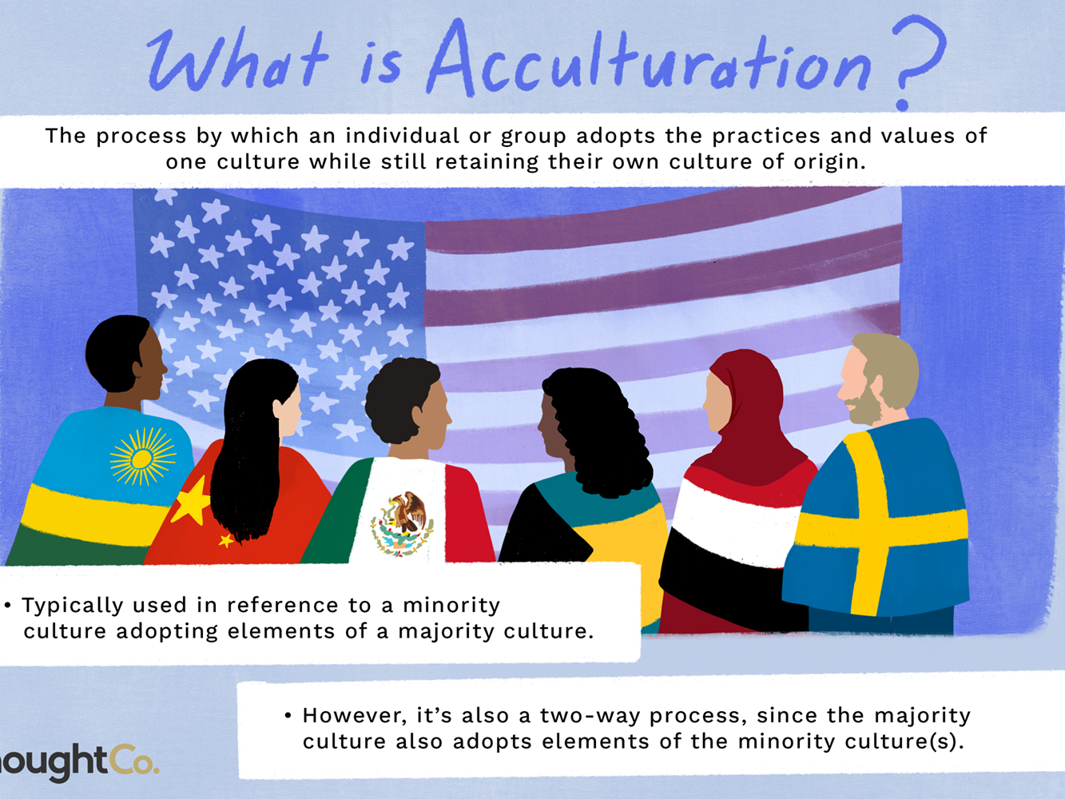  Culture Shock- an experience that the person feels when moving into a different cultural environment. It may also come off as a feeling of disorientation when an individual is suddenly subjected to a diol is moreofferent culture.  For example the person can’t easily adapt on the way of their living in the place he moved in.  Another example of how culture shock manifests is an individual being uncomfortable or not used to communication, food, weather, and public transport.  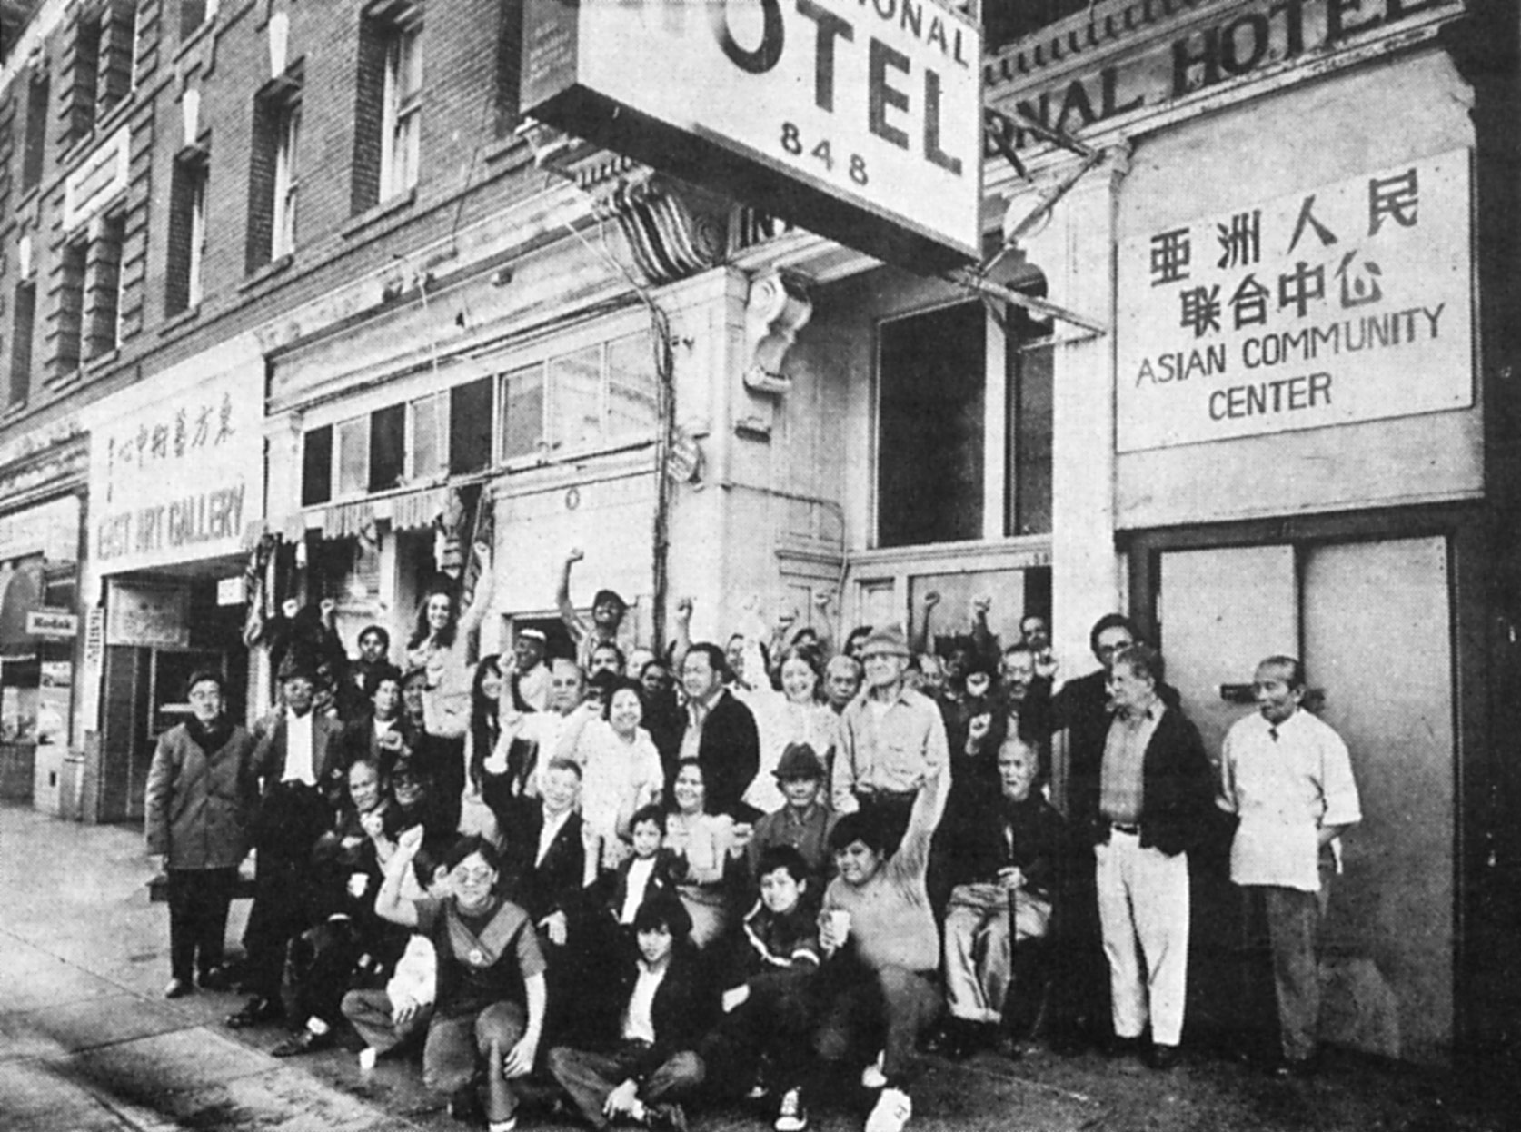 | STEM 1  Members: Perpose, Bautista, Mendoza, Nartea, Credo  Stem 2  Members:  Santos, Vargas, Pechon, Braga, Leano  Enumerate on the different functions of culture.Better if you can cite example/s of situation/s where the same function/s are being satisfied by culture.  1.Defines Situations  -for an example is if someone raised their right hand on their waist level some cultures think that it means shaking hands but maybe in some cultures it may mean to threaten someone.  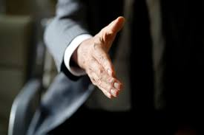  2.Defines Attitudes, Values and Goals  -as we learn the language, we also unconsciously learn the culture  Examples:  -po and opo  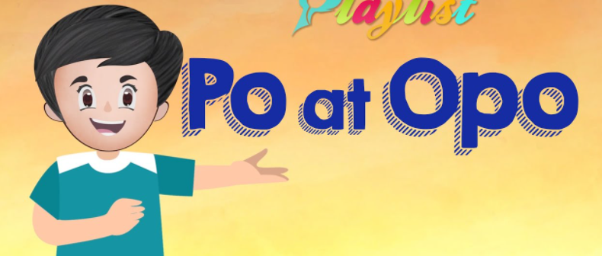  -bayanihan  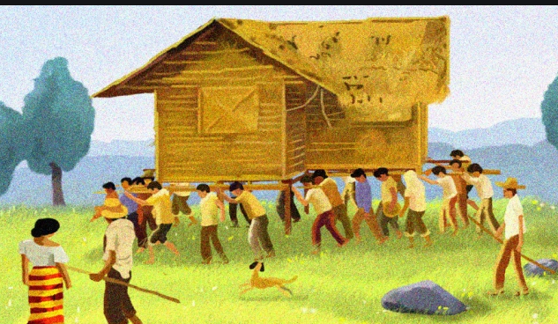  3.Defines Myths, Legends, and the Supernatural  Example:In the philippines we have manananggal tikbalang and many more we have different Myths, Legends, and the Supernatural in different culture  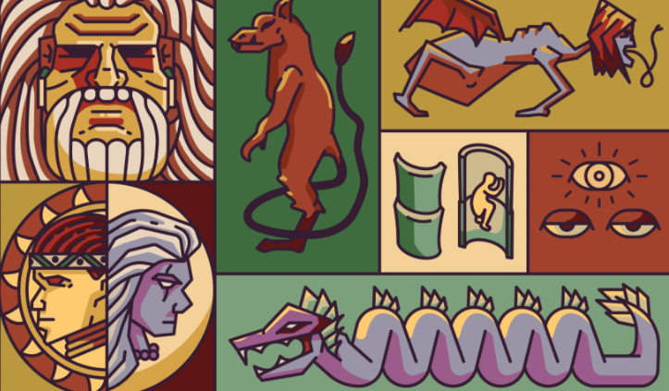  4. Provides Behaviour Patterns  ex. removing shoes or slippers before going in a house.  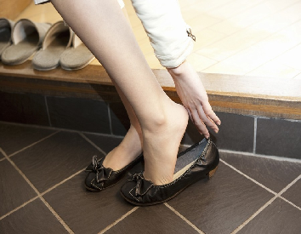  5. Culture includes attitude, values knowledge  Example:  When there is agreement with other people it is largely unnoticed, but when there is a disagreement or difference one is usually conscious of it. Your differences however, may also be cultural. For example, suppose you are a Catholic and the other person a Protestant.
Group 6
STEM 1
Members: John Paul Ramirez, Jejomar Aaron Teves, Aeron Brent Rabang, Rylie Buragay, Josef Sebastian
STEM 2
Members: Mohammad, Paragoso, Renolayan, Feliciano, Macaalay.
Describe each of the following:
Can you please add at least one example/manifestation for each?
Biocultural Evolution
- refers to the notion that there’s an interplay of biological and cultural factors that shape and react to evolutionary changes. exploration of the relationships between human biology and culture.
Humans live in cultural environments that are continually modified by their activities. Evolutionary processes can be understood only within this cultural context.
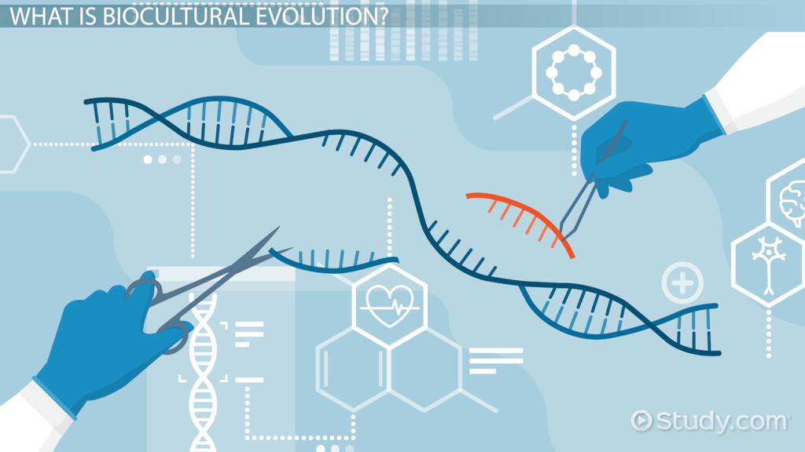
- Feliciano
Example:
-lactose tolerance
-Sickle-cell anemia

Socio-cultural Evolution
RAMIREZ(WITH PICTURE, AND MEANING)
-is defined as the permanent interplay between the evolution of social order,cultural achievements and cognitive ontogenetic development.
- "the process by which structural reorganization is affected through time, eventually producing a form or structure which is qualitatively different from the ancestral form".
Example:
-agricultural development
-technological development


